ECLAIRE CEH DATABASE
Simple guide to downloading data from the database (Reporting)
Contents:
To run an existing report 2
To create a new report 5
To find out which data fields are available for creating a report 12
To find out how much data is available for a site 15

Note: these notes were written for NitroEurope database.
ECLAIRE specific notes will be posted when they are available.
Meanwhile, these notes will help you navigate the report wizard for the ECLAIRE database.
To run an existing report
Click the “REPORTS” tab
If you have already created a report, then it will be listed under “Your Reports”
If you want to run a report that has been created for you (eg by a form manager), or one that you have made “public”, it will be listed under “Template Reports”
“Your Graphs” contains a list of reports that are defined as graphs (see later)

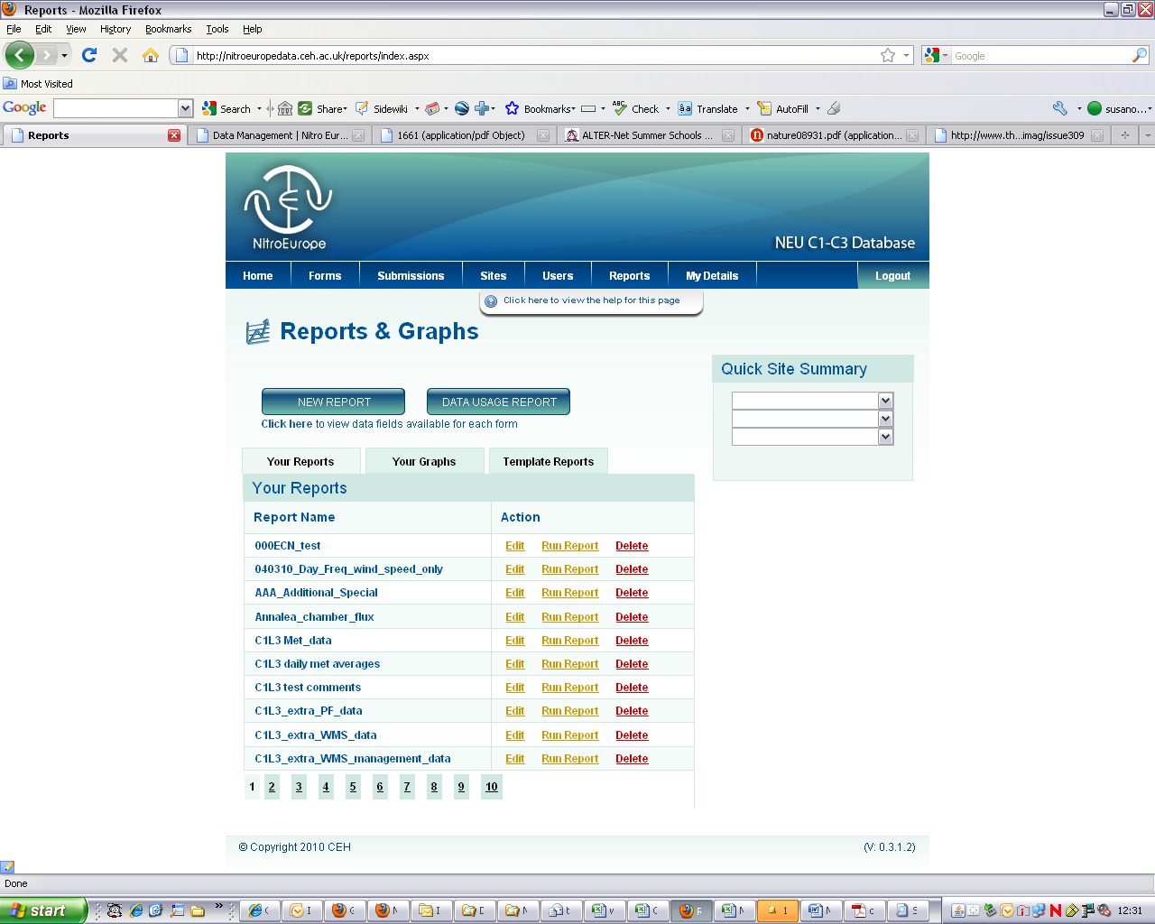
Click “Run Report” next to the report you want to run

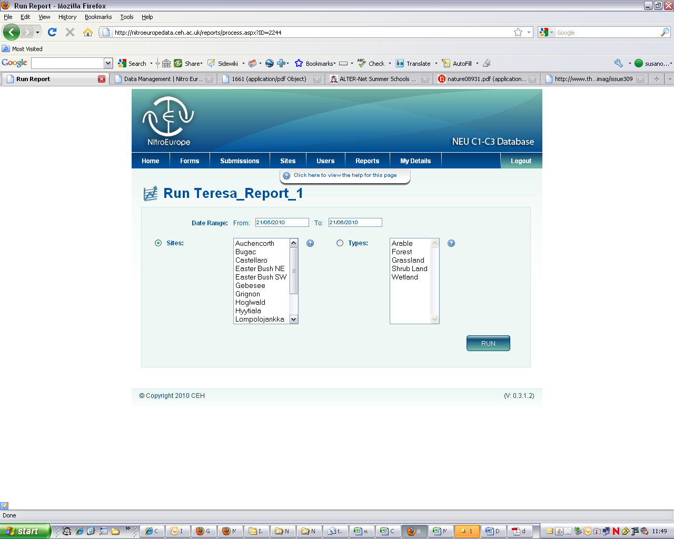
A new window appears:
- Fill in the date range you need here. If you want to see all time series data, it’s a good idea to type a very early date in the first box (eg 01/01/1900)

(2a) Select the required site(s) (hold down ctrl to make multiple selections).
OR (2b): You can select an ecosystem type. Be sure to click the “Type” button, and then highlight an ecosystem(s)
(3): Click “RUN”

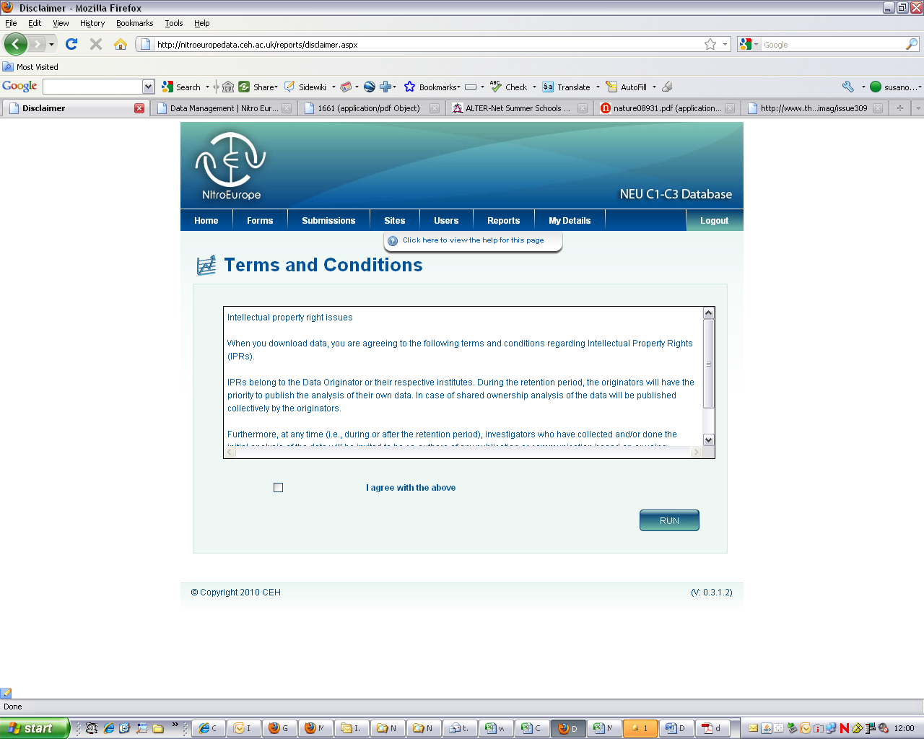

The IPR information appears. Click the “Agree” box and then click “RUN”

Your report will appear on the screen. There is a “DOWNLOAD” button to allow you to save the data in EXCEL. If you do this, an automatic message will be sent to all the PIs who own the data that you are downloading. This email will contain your name and email address so that can get in touch if they want to.

To create a new report
Click the “REPORTS” tab
Click “NEW REPORT”
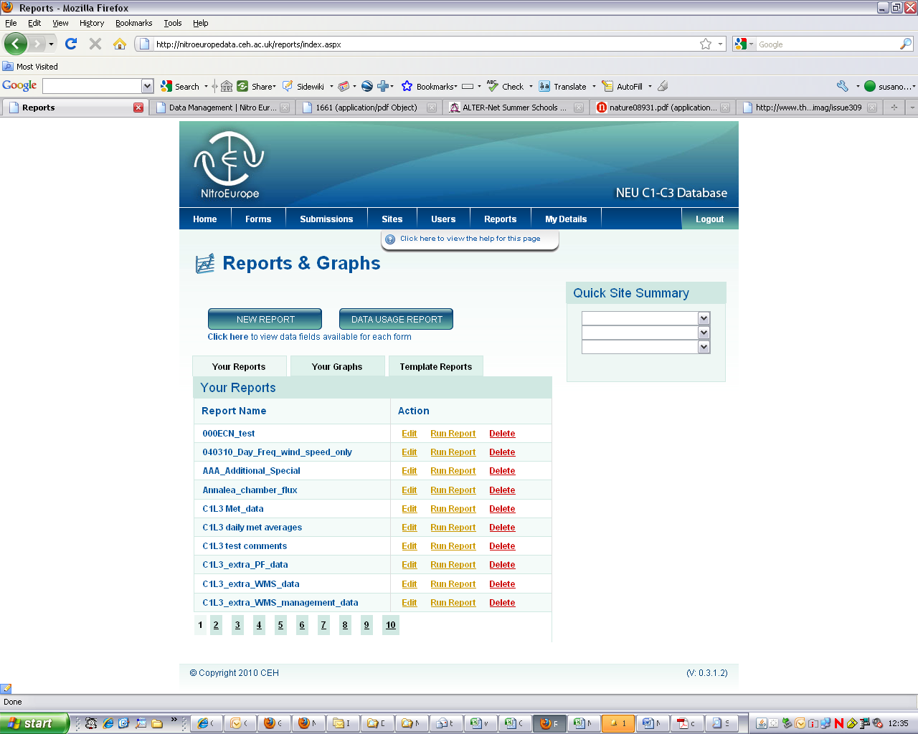

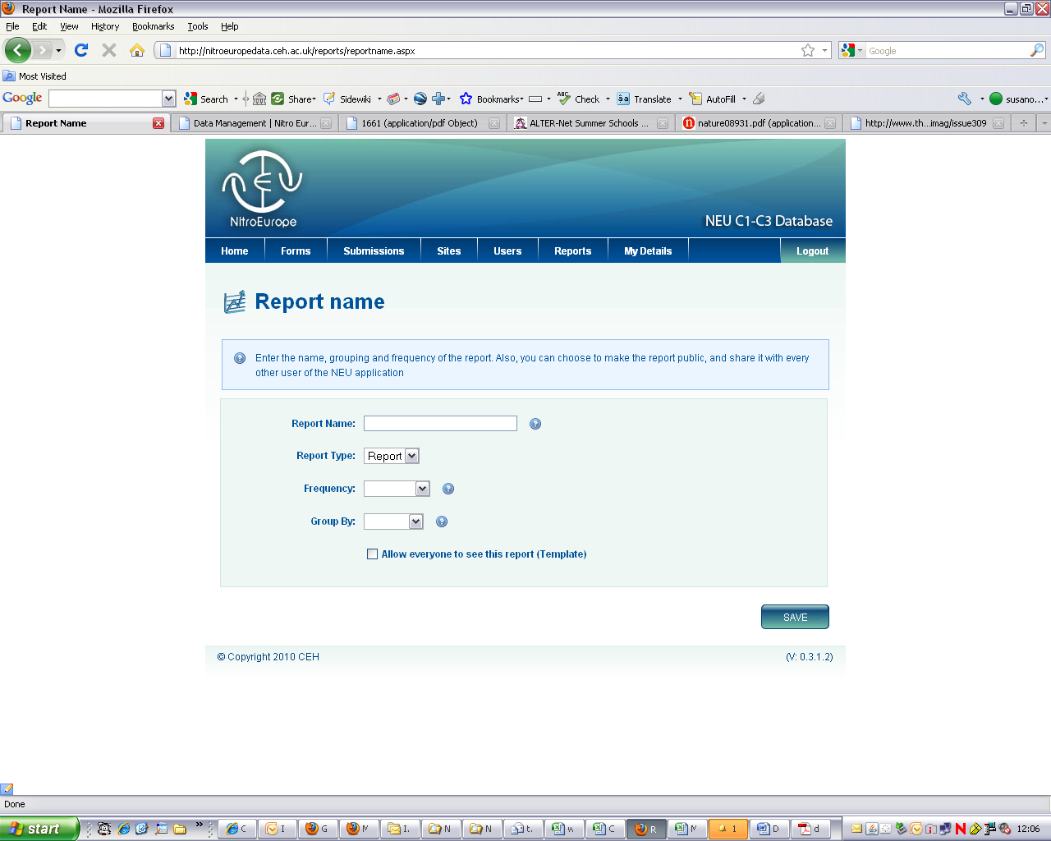

If you click here, the report will become a “template” and everyone will be able to see it
Type in a name for your report
(Optional: Frequency gives you “averages” eg hourly, and Grouping combines averages over a period eg day, so that an average diurnal trend (for example) can be obtained)

Here, select “Report” (for the data) or “Graph” for an online graphic view..

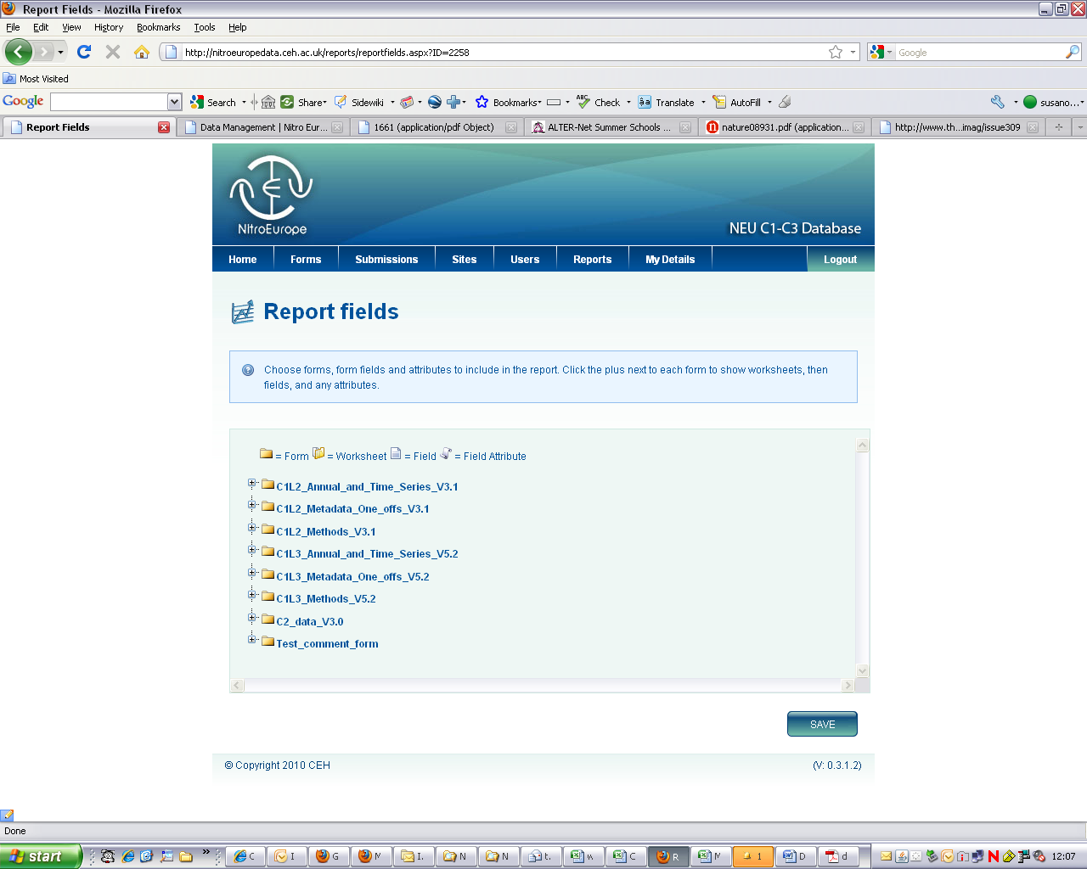

This window shows the list of forms available on the database.
They are named according to
i)NEU component/activity (eg C1XXX means Activity XXX data for component 1)
ii)type of data (eg “one-off”, or “time-series” etc)
Click against a form name to open up the list of “worksheets” it contains (The forms reflect the EXCEL data worksbook that the field scientists completed to upload)
Clicking against a worksheet name opens up the list of data fields in that worksheet

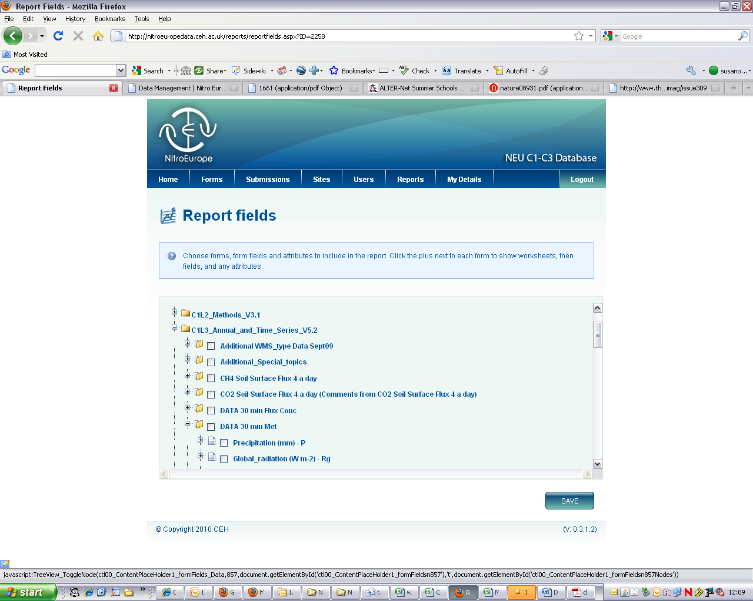

Here you can see that the worksheet “DATA 30 min met” in form “C1L3_Annual_and_ Time_Series_V5.2” has been clicked and you can see the first meteorology data fields. Note the scroll bar on the right to reveal more data fields below.

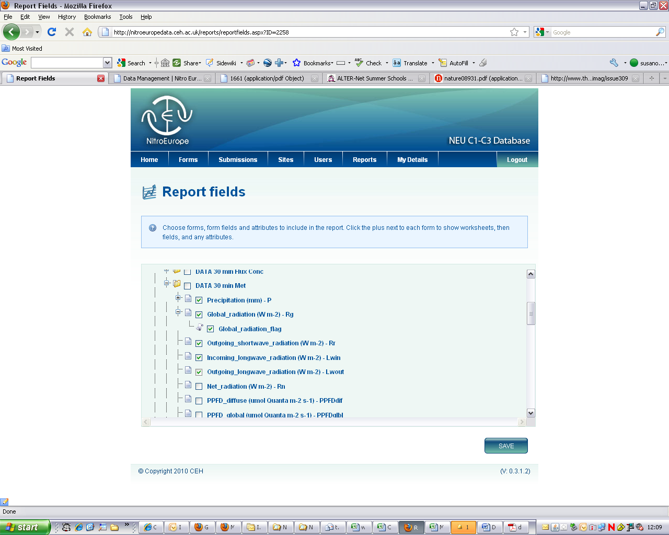

Scroll down to see more fields in this database form. Click against the fields you want data for.
Notice that you can sometimes click against fields to open up an “attribute” list (eg data flag, stdev…..)
You can select fields (and their attributes if you want) from more than one form
BE CAREFUL NOT TO SELECT TOO MANY FIELDS IN ONE REPORT or you will exceed the system capacity. It’s easy to create 2 or 3 (or more) reports to get all the data you need.
Click “SAVE” when the report is complete

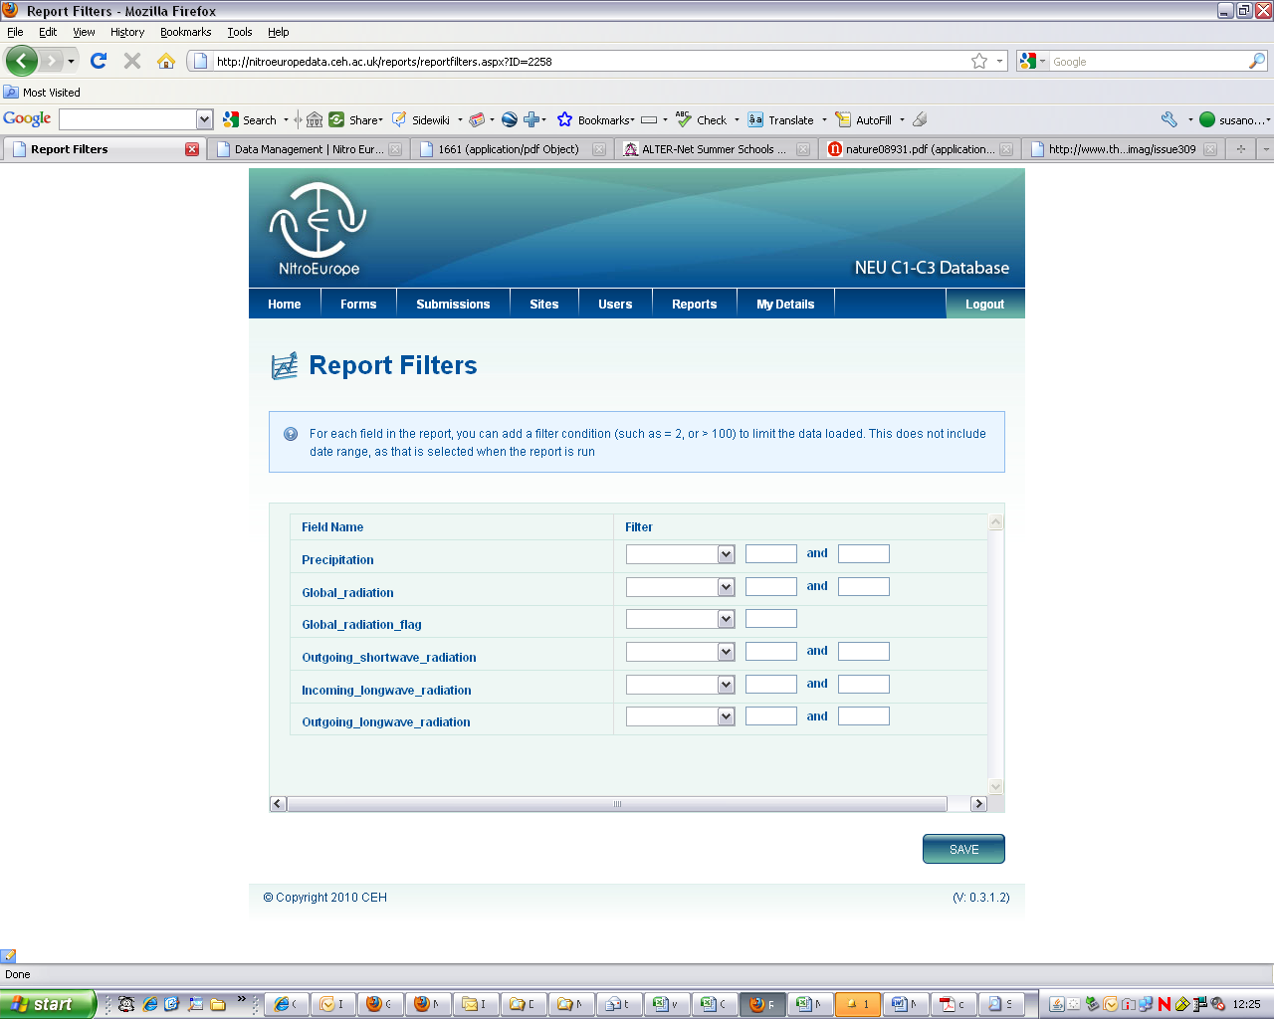

This screen allows you to set filters on the reported data. This is optional
Click “SAVE”

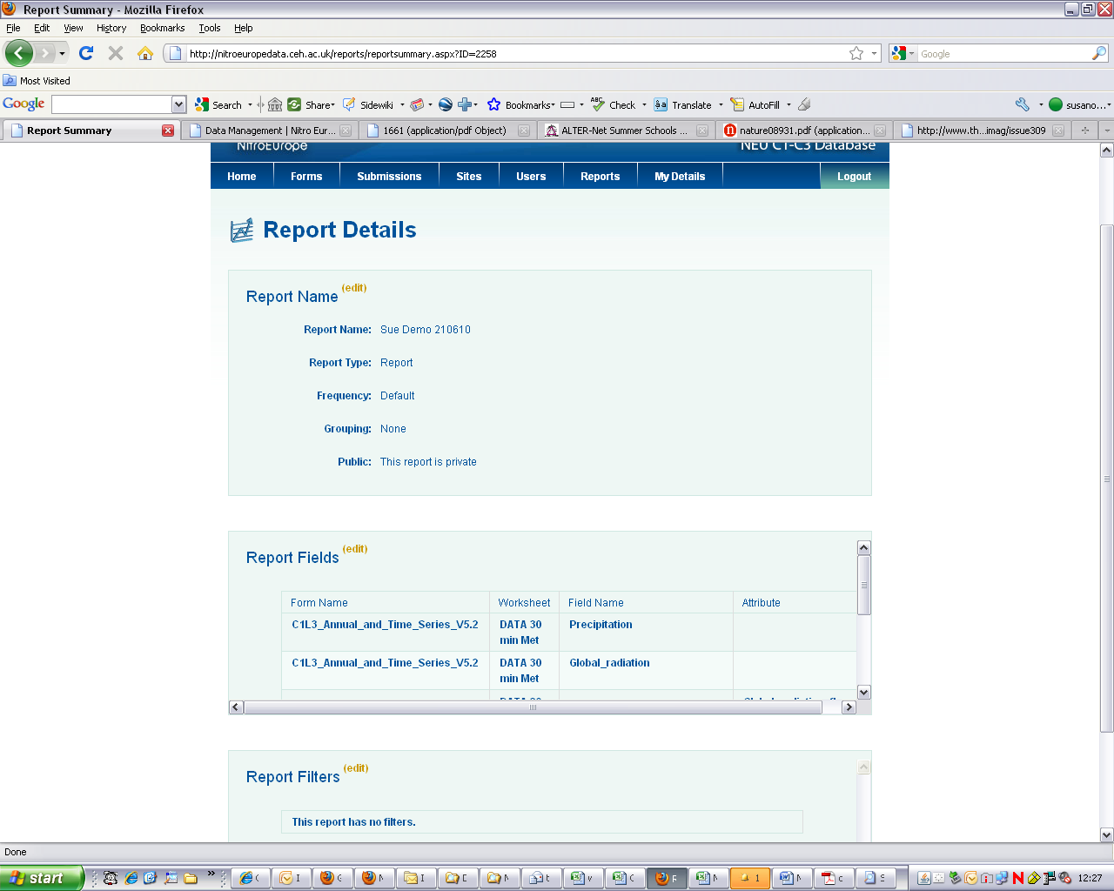

The report is now ready. Scroll down to click “DONE” or to “RUN REPORT”
If you click “DONE”, the report will be listed in “YOUR REPORTS” or “TEMPLATE REPORTS” (if you specified that everyone could see it)
Note the small “Edit” links in each report section. Click these to change any details.

To find out which data fields are available for creating a report
Click here!
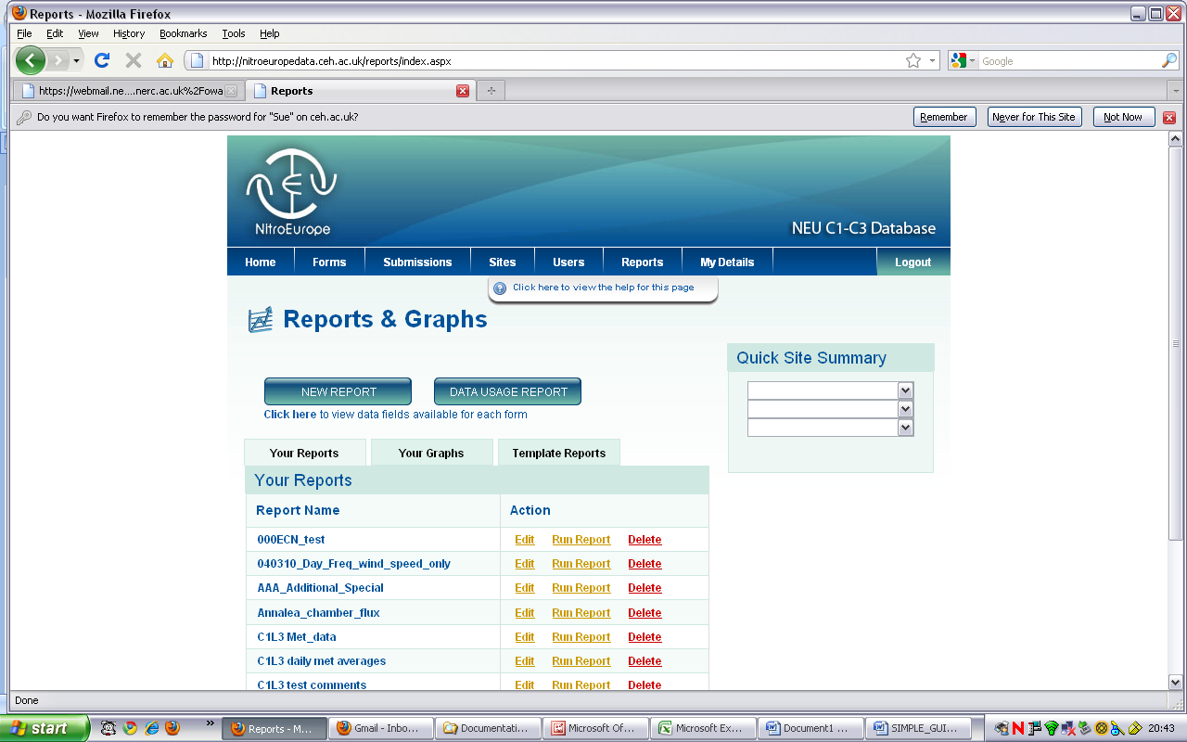

This leads to another window:
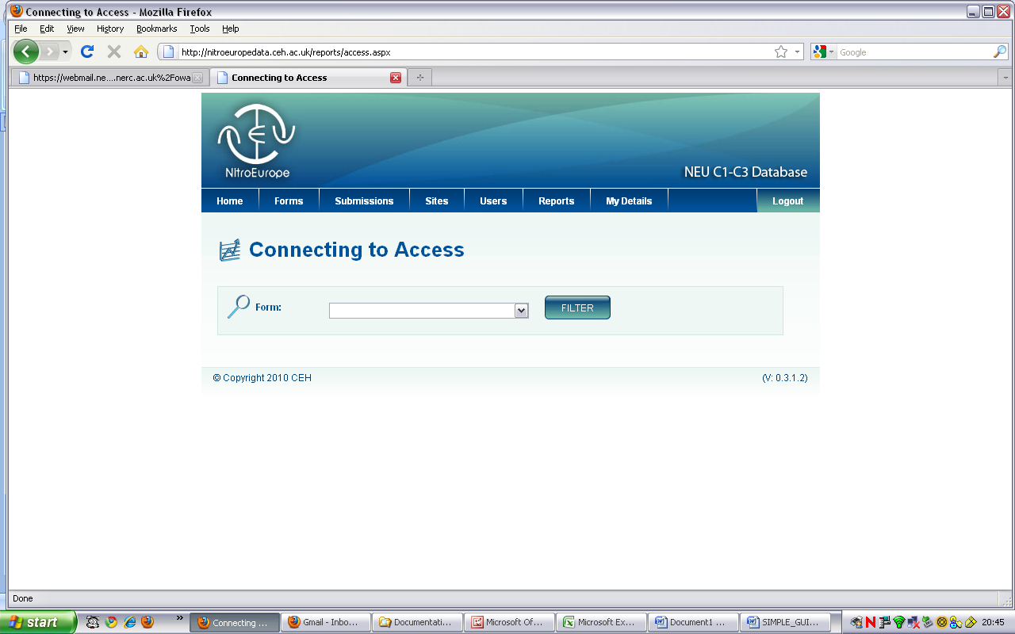
Use the drop-down menu to select a form to search:
These are named according to the NEU Science Component/Activity
…and also type of data

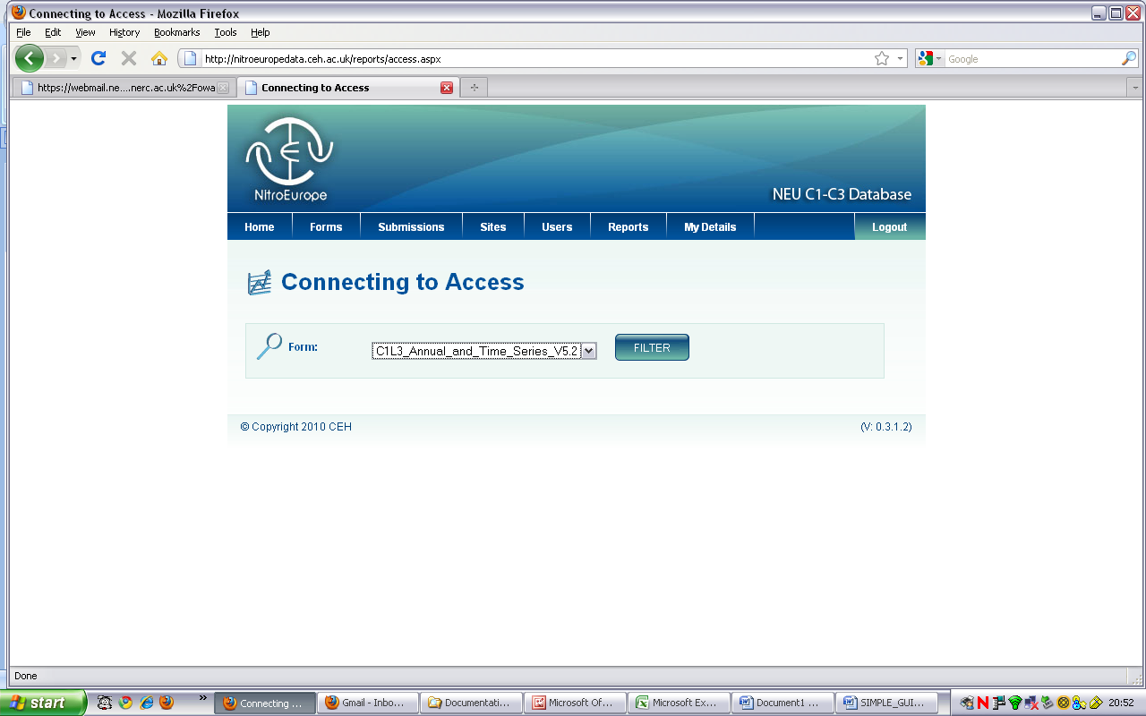
I’ve decided to see what time series data there are from C1L3
I’ve chosen the right form, and now press “FILTER”
A window appears, with horizontal and vertical scroll bars. You can browse the contents of this window but it’s easier to download to EXCEL, because there are a lot of data fields in the time series. So click “Save to EXCEL” (the button at the bottom left hand side)
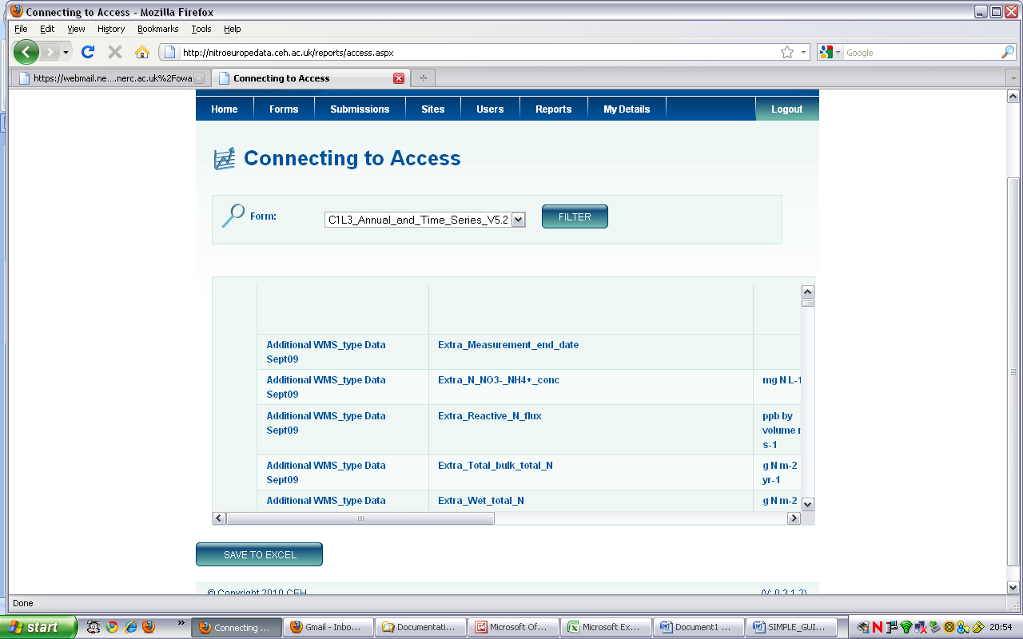

This is what the downloaded EXCEL file looks like:
Scroll down the file to see the “worksheet”names in Column A

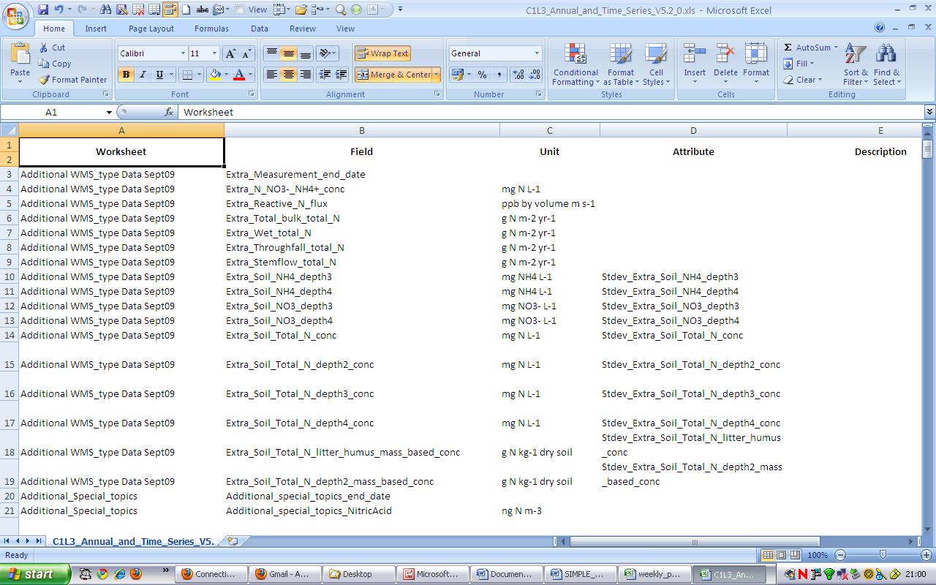
These are the data field names – for C1 activities, the names are descriptive. However, some field names are still not easily understood. A Guide to Data Fields will be available soon
-For C2, the names are coded – but there is a description column (E)

Browse the list of Data fields, make a note of the field-names and their worksheets for the data you want, and you can now design your report, as described in the first part of this guide.

To find out how much data are available for a site
Use these drop-down menus to select Form (top row), Worksheet (bottom row) and Site (middle row)
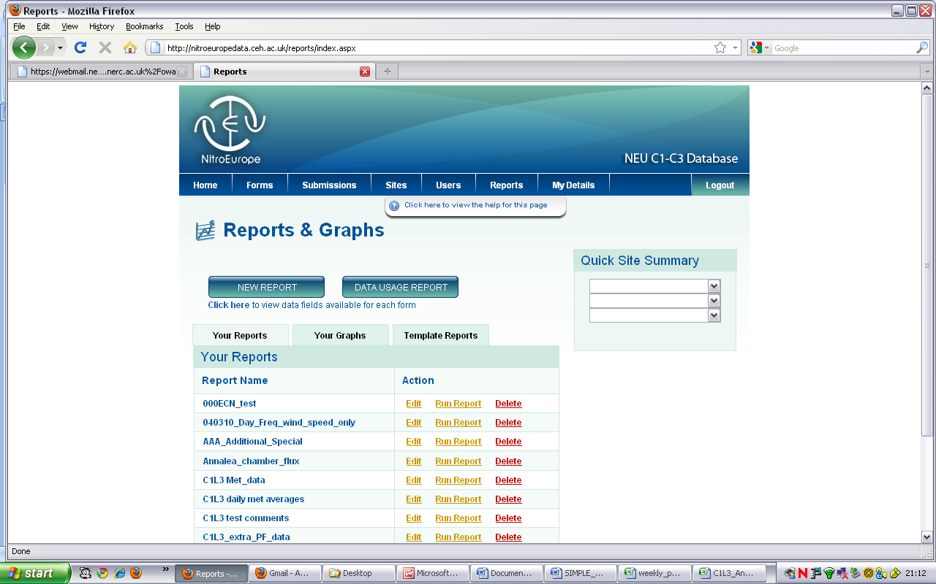

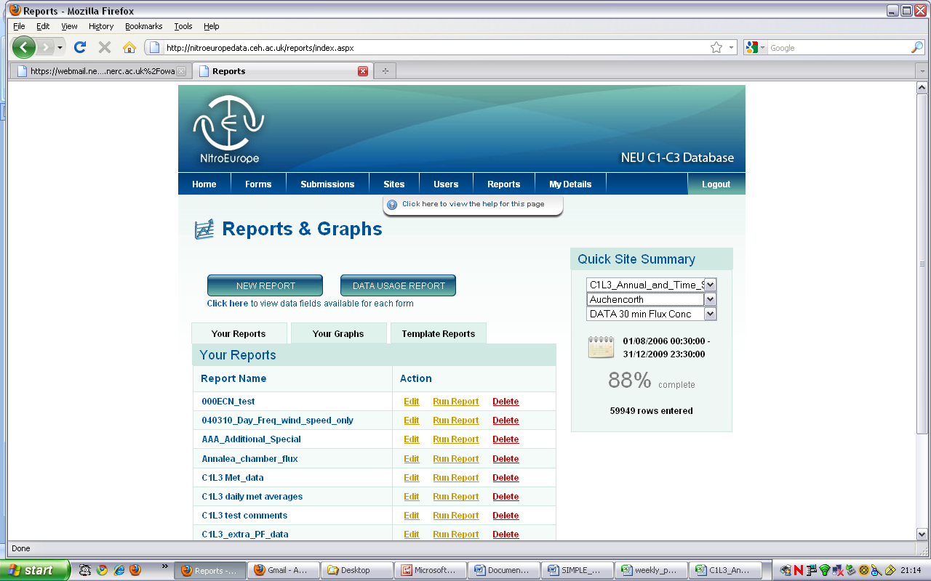
This gives the date range for that Form/Worksheet/Site and the number of data rows. The percent value gives an idea of the total number of fields in the worksheet that contain any data at all

