

Work Package 10/11

Guide to downloading data

Contents

Introduction Page 2

Database form names Page 2

Downloading data instructions Page 3

Running the Download Report Page 6

IPR Page 8

Report List Page 9

Appendix A - Key fields for each worksheet of the WP10/WP11 data template
Page 10

Instructions for downloading data for ECLAIRE WP10 and WP11

Introduction
The database software that you will see when you log on (see below for log-on instructions) was commissioned to cope with Data Management for large European projects and it is particularly good for long term time series data. The software is an interface between your completed EXCEL templates and an Oracle database which builds up “behind the scenes” as data are uploaded.
Downloading is driven by the “Report” function, where you can select data fields and specify sites and time intervals for the data you want to download.

The database contains different “forms” which contain data from the different completed EXCEL template worksheets for different ECLAIRE work packages.

The database form names for ECLAIRE WP10 and WP11 are listed here:

Database “form”
Site Metadata and Treatments for manipulated ecosystems

Methods for manipulated ecosystems

Vegetation data for manipulated ecosystems
Soil and leaching data for manipulated ecosystems

Deposition data for manipulated ecosystems

Meteorology for manipulated ecosystems

DO3SE model evaluation data

Gas and water exchange data for manipulated ecosystems and plants

ACi and AQ data for manipulated ecosystems

How to download data - Instructions

- Log onto the database (http://eclairedata.ceh.ac.uk/). This is also accessible from the “data” tab of the ECLAIRE website (http://www.eclaire-fp7.eu/)

- Click the button or tab “View Reports” or “Reports” (Figure 1)

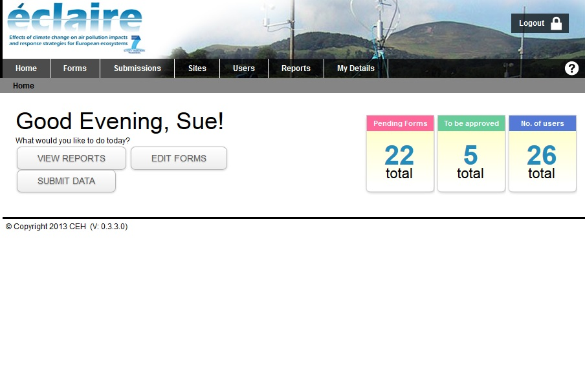

2. OR/ Select “Reports” here

1. Select “VIEW REPORTS” here

Figure 1: Click “Reports” to download data

- Click “New Report” (Figure 2).

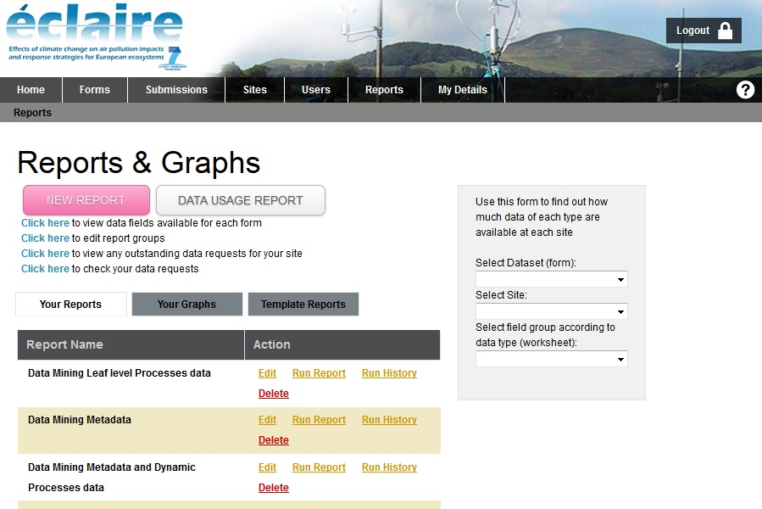

Click “NEW REPORT”

Figure 2: Click the “NEW REPORT” button

4. Give the report a meaningful name. There is no need to do anything else on this screen for now. (Figure 3). For advanced options, download the general Report Guide from the ECLAIRE web pages.

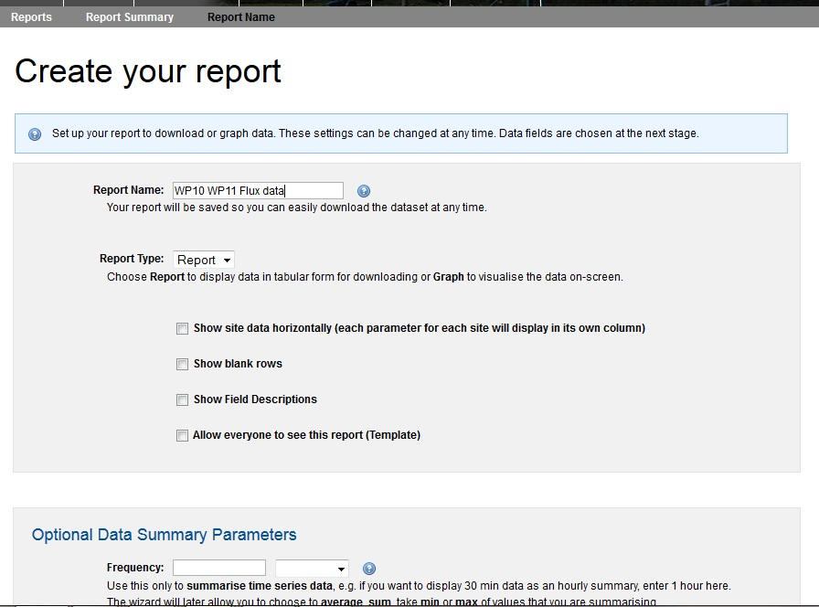

Type in a name for the download report.

IGNORE for now

Click the green SAVE button at the bottom of the screen

IGNORE for now

Figure 3: Name the report; ignore other options; click “SAVE”

5. The next window will list the available database forms. Most WP10 and WP11 forms have the words “manipulated ecosystems” in their name (the exception is the form containing data to evaluate the DO3SE model). The form names indicate the type of data to be found within. Click the small “+” next to a form name to expand and reveal the “worksheets” in that form (Figure 4).
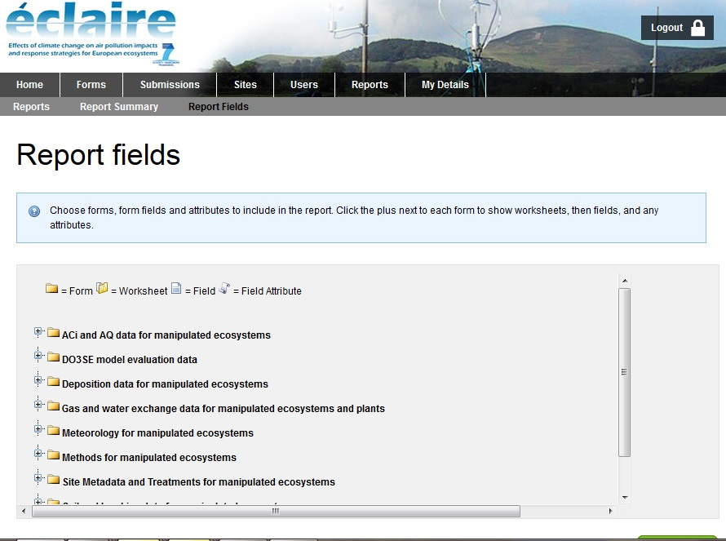

Click the small “+” against the forms whose data you are interested in

Figure 4a: Selecting and expanding Forms
The list of “Worksheet names” reflects the EXCEL worksheets that the data uploaders completed. Within the worksheets are the data field names. Once these are revealed, you can check each data field that you would like to download (Figure 5).

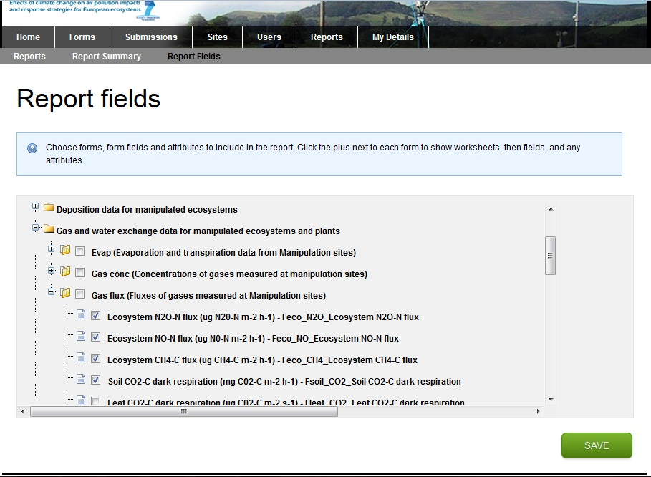

1. This form is expanded to show 3 “worksheets”. These correspond to the EXCEL worksheets completed by the uploader.

2. Click the “+” next to worksheets of interested to reveal a list of data fields.

3. Check against each data field that you want to download

Figure 5: Expanding forms to reveal “worksheets”, and expanding “worksheets” to reveal data
fields for downloading

In theory, you can select fields from more than one form and more than one worksheet in one download report. In practice, this might lead to difficulties until you understand the data. We therefore advise that you download data from only one form and one worksheet at a time. You will need to think about meaningful and coherent naming of your reports in section 4. Click the green SAVE button when you have made your selection of data fields.

6. You can ignore the next screen “Report options and filters” for now. Refer to the general guide to downloading for these more advanced features. (Figure 6). Click the green “SAVE” button.
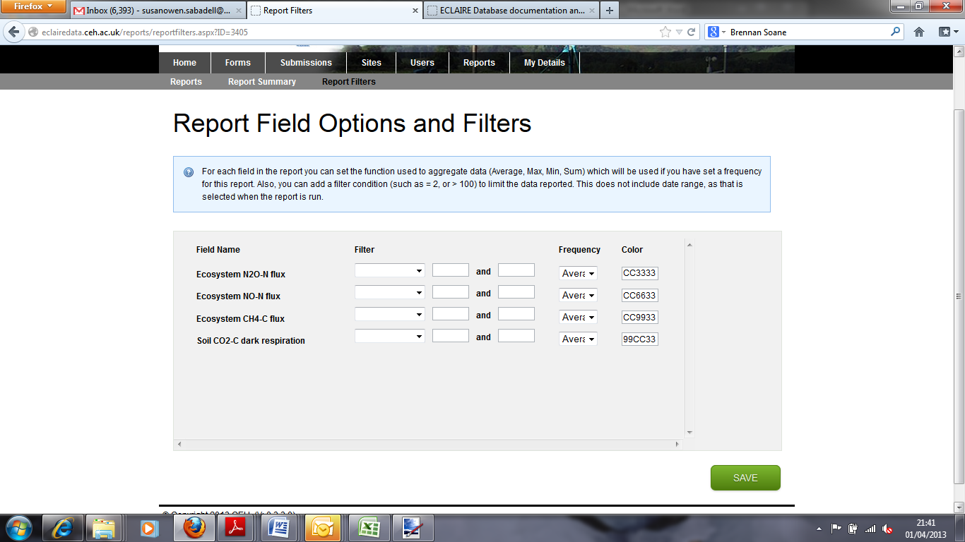

Figure 6: Report Field Options and Filters: ignore for now

7. The download report is now ready to run. A summary is displayed (Figure 7) and there are options at the bottom to “Close” (and run the report another time), or to “Run report”.
Click the “Run report” button.
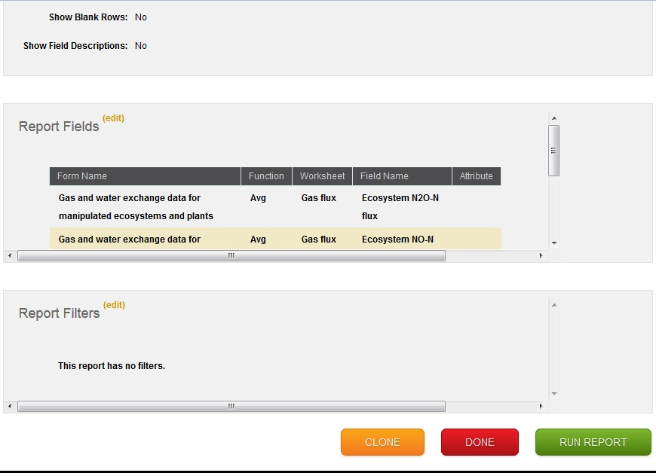
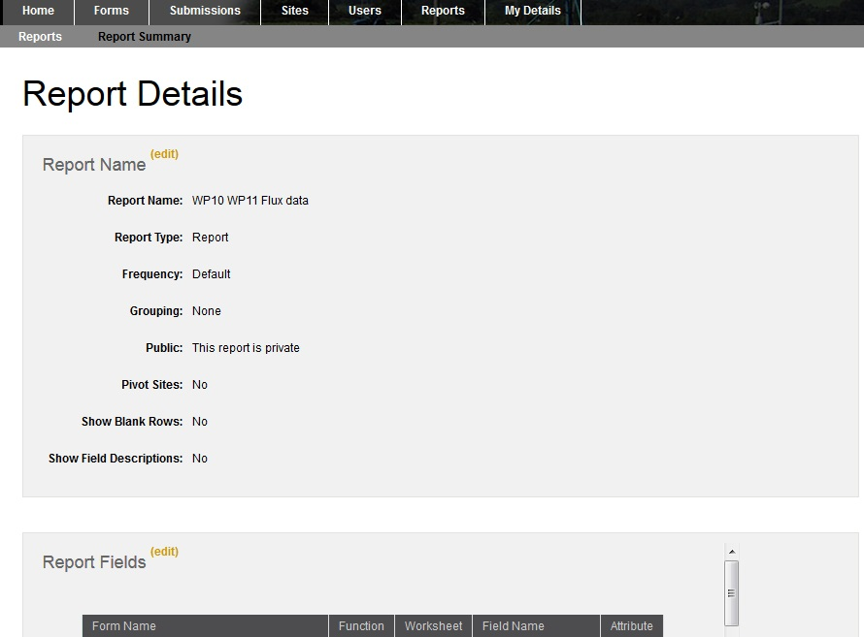

Figure 7: Download report summary; ready to “run report”

Running the Download report

8. Running the report (Figure 8): A window appears where you need to:
i/ select a date range for the data you wish to download;
because of occasional anomalies in uploaded data, you are advised to select
a start date which is some years before your date range of interest.
ii/ select one or more sites for data download
you can select multiple sites by holding down the “ctrl” key while click selections)
(Figure 9)

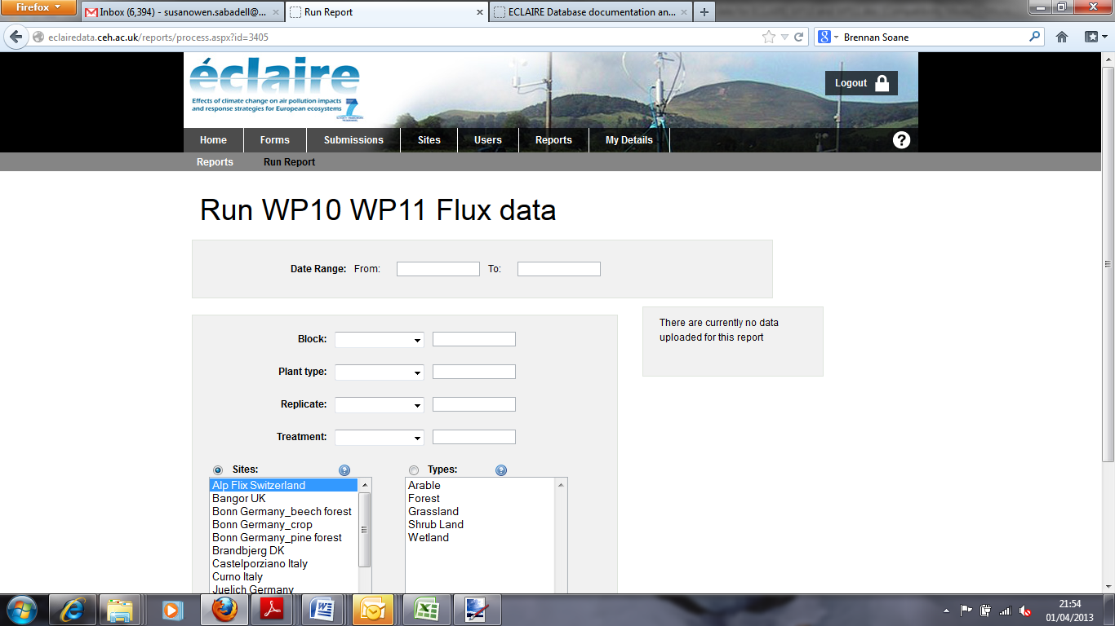
1. Click and enter a date range for data to download. Select an early “from” date to make sure you capture all data

Figure 8: Running a report -1: selecting date range and site(s)

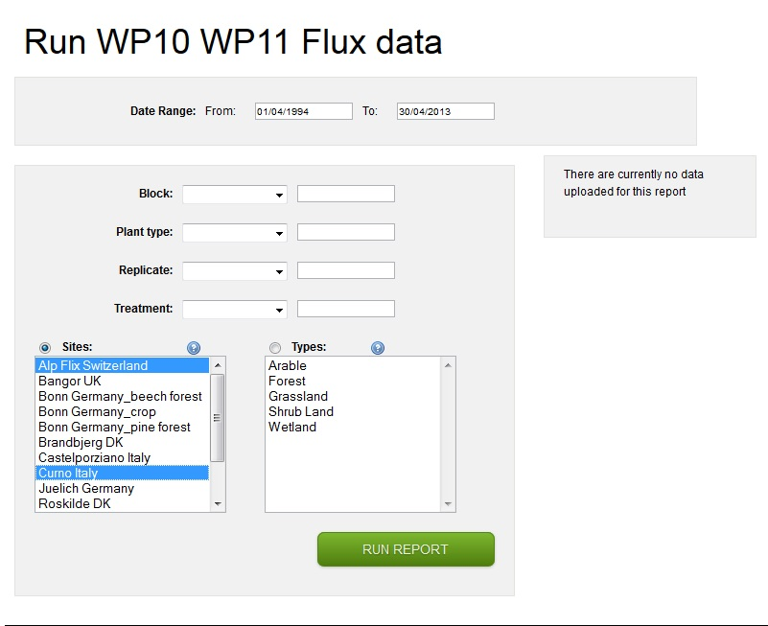

Ignore these options for now.

1. Hold down the ctrl key while selecting multiple sites.

2. Click “RUN REPORT”

Figure 9: Running a report -2: date range and site(s) are selected

IPR

10. A window with an IPR disclaimer appears. Please click the box to proceed. You are agreeing to contact the data owner should you wish to use the data for any publication or reporting purpose. (Figure 10).
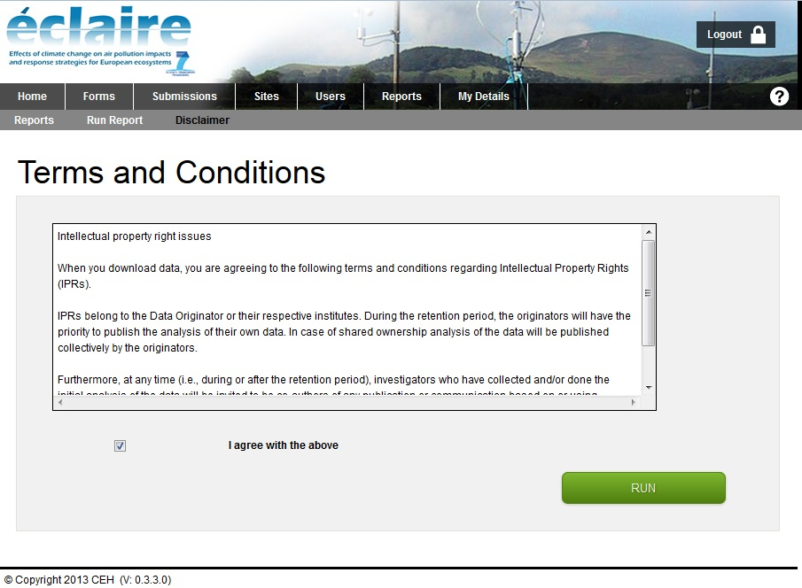

Figure 10: Agreement for ECLAIRE IPR when downloading data

11. The downloaded data appear on the screen (Figure 11). You have to option to download (as EXCEL or CSV). If you download data and automatic email will be sent to the PI to inform them you have done this.
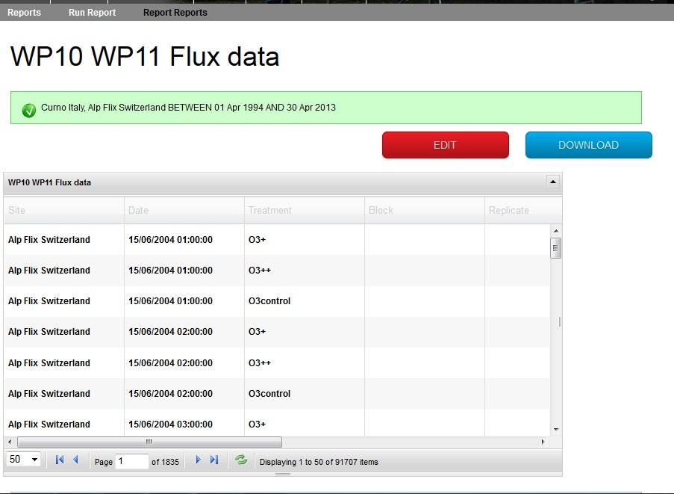

Figure 11: Downloaded data displayed on screen ready for downloading to EXCEL or csv

List of reports

12. Finding your report to run again (eg with newly uploaded data, or different sites).
Once you have defined your Download report, you can find it in your list of reports after clicking the button or tab “View Reports” or “Reports” (part 2, Figure ; Figure 12). Clicking “Run” will take you to section “8”. Clicking “Edit” will take you to section “7”, and you can click the small “edit” button for each section to change (eg) the report name, or the selected fields.

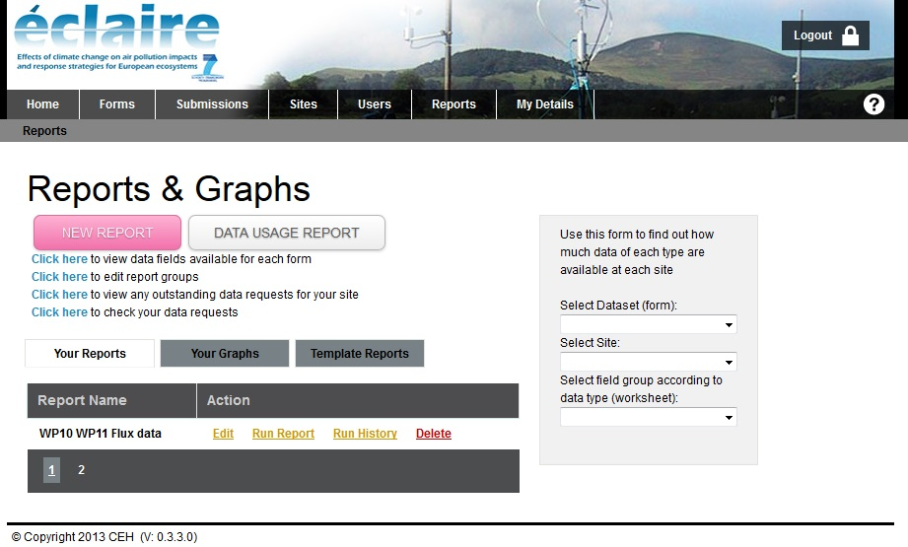
Figure 12: Reports listed by name; displayed after clicking “View Reports” or “Reports”
APPENDIX A - Key fields for each worksheet of the WP10/WP11 data template

Please ensure each row of data has a unique combination of values for the key fields in each sheet
Worksheet name | Key fields
Site | None
Methods | None
Veg | Time  Treat  Block  Replicate  Plant_type
Species | Time  Treat  Block  Replicate  Species
Litter | Time  Treat  Block  Replicate  Plant_type
Soil prop | Time  Treat  Block  Replicate
Soil chem | Start_time  End_time  Treat  Block  Replicate  Soil Layer number
Leach | Start_time  End_time  Treat  Block  Replicate
Depos | Time  Treat  Block  Replicate
N Fix | Time  Treat  Block  Replicate
Met | Time  Treat  Block  Replicate  Height
Model_Eval_data | Start_time  Treat  Block  Replicate  Plant type  Soil Layer number
Gas conc | Start_time  Treat  Block  Replicate
Gas flux | Start_time  Treat  Block  Replicate  Plant type
Evap | Start_time  Treat  Block  Replicate
AciAQ | Time  Treat  Block  Replicate  Plant_type  Leaf_age  Leaf_pos

