

Work Package 1 – Field monitoring

Guide to uploading data

Contents

Introduction Page 2

Database form names and corresponding EXCEL worksheets Page 2

Uploading data preliminaries (important) Page 3

Uploading data instructions Page 3

“Warning” and “Fatal” upload errors Page 6

Appendix A - Key fields for each worksheet of the WP10/WP11 data template
Page 8

Instructions for uploading and downloading data for ECLAIRE WP1 – Field monitoring

Introduction
The database software that you will see when you log on (see below for log-on instructions) was commissioned to cope with Data Management for large European projects and is particularly good for long term time series data. The software is an interface between your completed EXCEL templates and an Oracle database which builds up “behind the scenes” as your data are uploaded.
Uploading your EXCEL templates is easy. The uploader simply follows instructions in a short series of user-friendly screens.
There is a “Report” function, also driven by a series of user-friendly screens where downloaders can select data fields and specify sites and time intervals for the data they are interested in.

The database contains different “forms” to receive different completed EXCEL template worksheets from different ECLAIRE work packages.

The database form names are listed here:

Database “form” | EXCEL worksheets which upload to this form
Site Metadata for field monitoring | Metadata; Site Information;
Ecosystem Management for field monitoring | Ecosystem Management Details
Methods and comments for field monitoring | Methodology; Your Submission comments
Soil and leaching data for field monitoring | Soil properties; Soil NO3 and NH4 profiles
Soil gas flux for field monitoring | Soil gas flux NO; Soil gas flux NO2; Soil gas flux O3; Soil gas flux CO2;
Soil Meteorology for field monitoring | Meteorology soil temp profile; Meteorology soil water profile
Vegetation data for field monitoring | Vegetation data
Deposition data for field monitoring | Wet deposition
Gas and water exchange data for field monitoring | Gas Flux and Concentrations; VOC flux
Meteorology for field monitoring | Meteorology-30 min; Meteorology-1 min
Within-canopy data for field monitoring | Canopy CO2; Canopy RH; Canopy leaf CO2 and H2O; Canopy O3

Uploading data preliminaries

1. The template you have completed contains several different worksheets which are uploaded to the database forms listed above. Using the table above, you will need to perform the “upload” routine described below for each database form listed. You need only upload to the forms where you have data in the corresponding EXCEL template worksheets.

2. The database is awaiting your data.
I need to set up a “submission date” (ie a submission “opportunity”) for all sites for all database forms.

Please send me a list of your files for uploading, with the start date of the time series data.
(susa1@ceh.ac.uk).

Please note that each row of data should have unique values for the “key fields”. These are listed for all worksheets in Appendix A to this document

How to upload data - Instructions

- When you have sent me your list of files for uploading, with the start date of the time series data, wait for me to contact you to tell you that your “Submission Dates” are ready.

- Log onto the database (http://eclairedata.ceh.ac.uk/). This is also accessible from the “data” tab of the ECLAIRE website (http://www.eclaire-fp7.eu/)

- Click the button or tab “Submit data” or “Submissions”

- In the first drop down search boxes at the top of the window, find the form (from the ones listed above) that you want to upload data to. In the second drop-down window, find your site. Click “search”. (Figure 1)
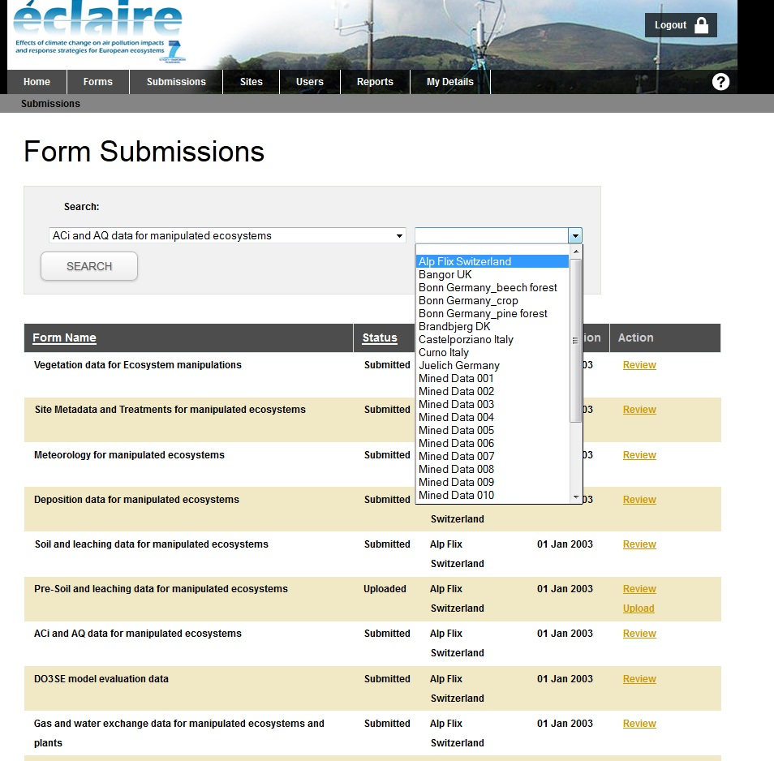

1. Select the relevant database form here

2. Select your site here

3. Click “SEARCH” when you have selected form and site

Figure 1: selecting form and site

- Find the “Submission date” that matches the data you are uploading (it should be the first date of the time series data in your template), and click the “upload” button at the end of the line in the “actions” column (Figure 2).

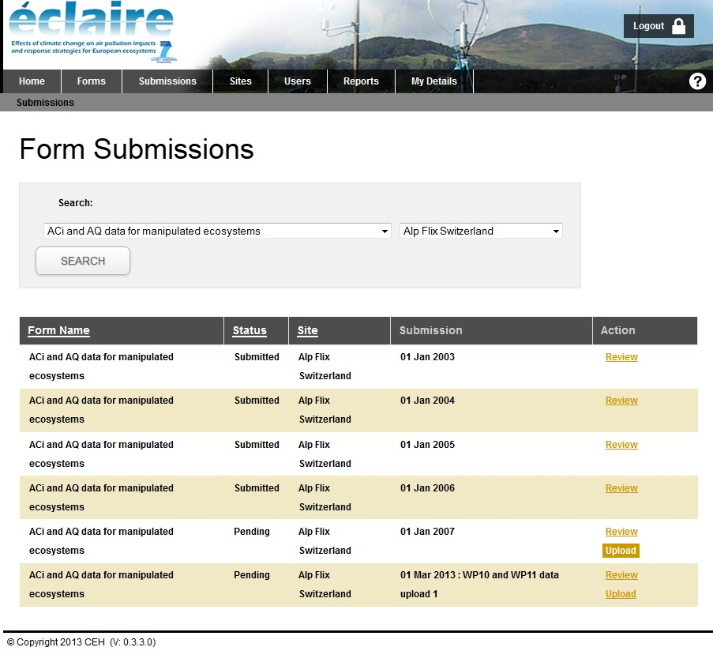

Find the relevant “Submission date” to match the beginning of your time series data

Click the “upload” button next to the selected “Submission date”

Figure 2: Click the “upload” button

- Follow the on screen prompts.
(Please *never* click the red “Dismiss upload” button. We will be removing this option. It leads to a very time consuming process that may lead to your system “freezing.”)

(i) You will first be asked to browse for the data file you are uploading (Figure 3)

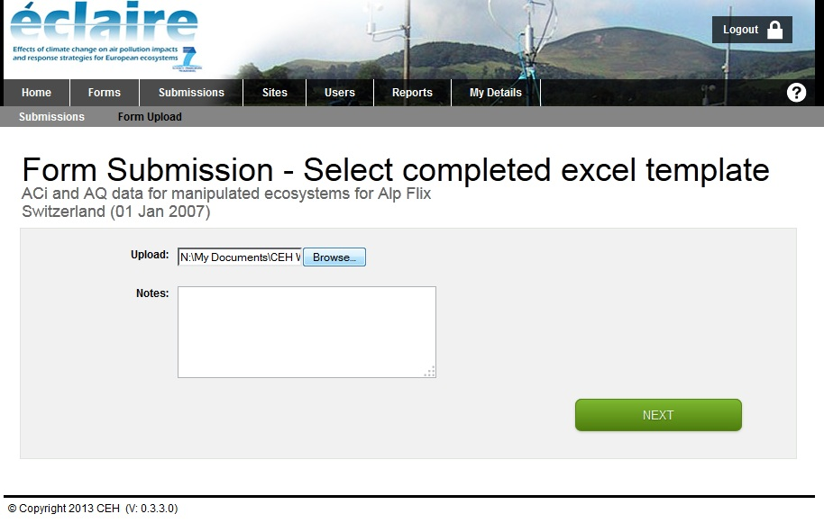

Browse for your file to upload

Press the green “NEXT” button when you’ve browsed for the data file

Optional comments for your upload
eg “re-uploading corrected file”

Figure 4:
Optional - attaching other relevant files eg jpg or relevant pdf

Figure 3: Browse for completed template

(ii) You will be asked if you have any files to append to the upload. This does NOT include the data file that you are uploading – that has already been picked up. This is an option if you have figures or tables that might be useful, or any other documentation, this is where you can attach files. (Figure 4)

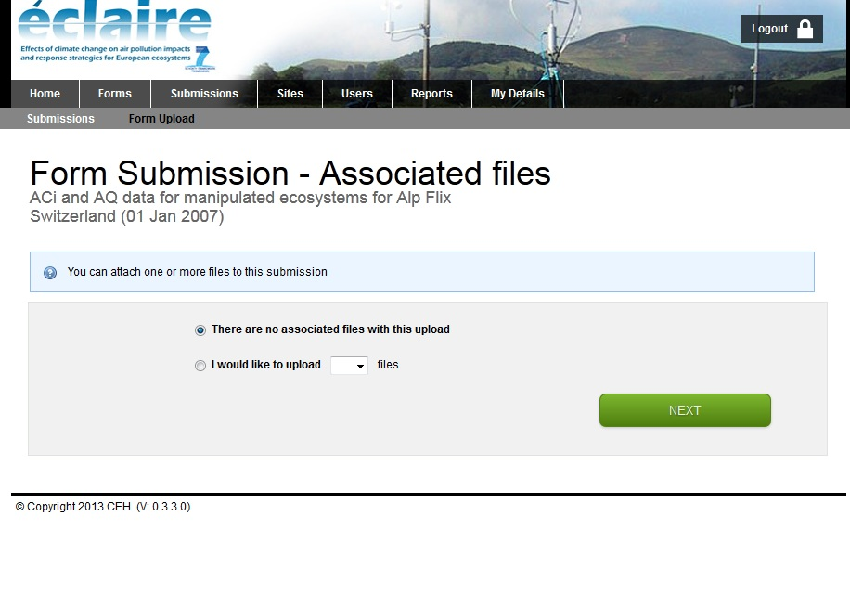
1. Click here if you want to attach other files, eg relevant pdf or jpg

2. Select the number of files you want to upload. This will make browse windows appear for you to select all the files you want to attach.

3. Click the green “NEXT” button

Figure 4: Option to attach other files

(iii) You will be asked to set “Download Permissions”. Please ALWAYS check the “ECLAIRE general” user group box. (Figure 5).

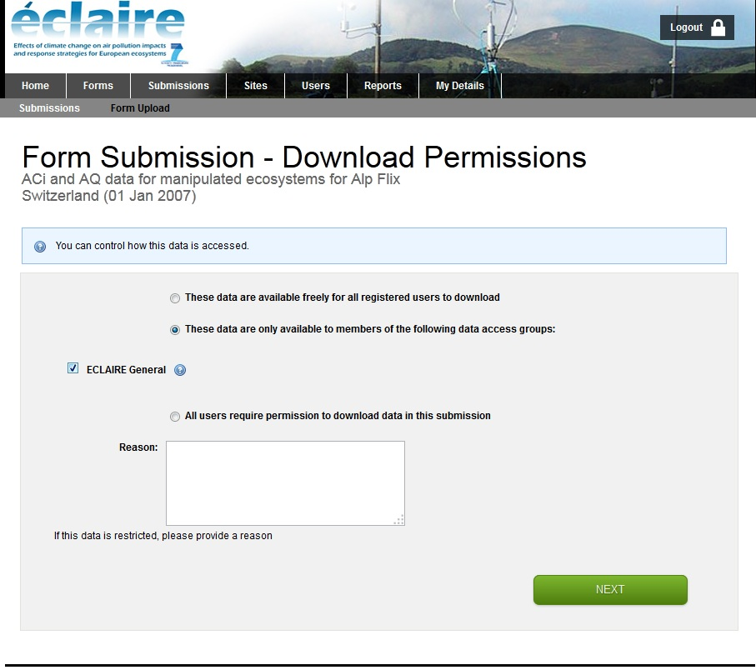

REQUIRED!
Please check “ECLAIRE General” .
This limits visibility of your data to the ECLAIRE community

Figure 5: Set download permissions: please select “ECLAIRE General”

(iv) If there are no “errors” appearing on the screen, then you can select “Save and Submit” and click the green “DONE” button (Figure 6).

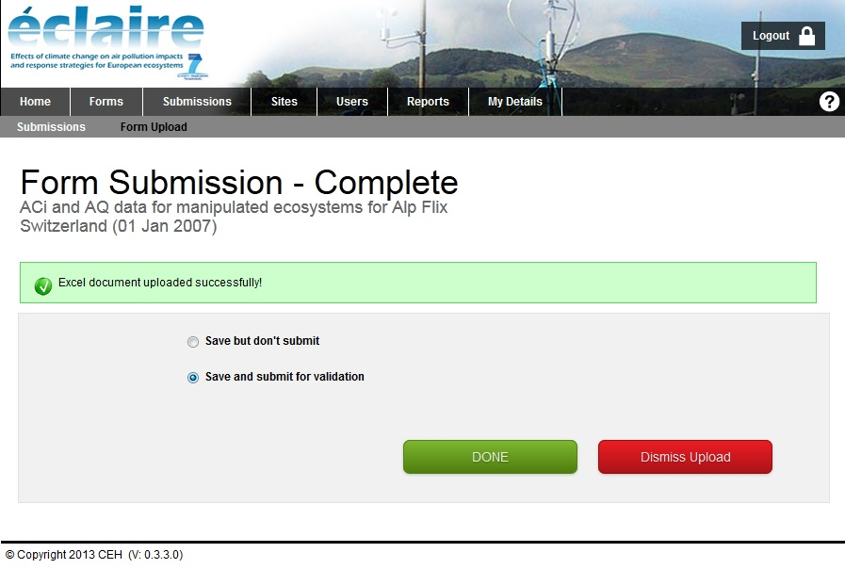

Figure 6: “Save and Submit”

(v) “Warning” and “Fatal” errors
If there are problems with your data (for example, different rows of time series data with the same date/time value; values of fields outside a set range), then an error report will appear on screen. This can be downloaded to EXCEL if it’s too long to deal with on screen.

- “Warning” errors appear with options to “Save but don’t submit” or “Save and submit for validation”. Select “Save but don’t submit” if there are errors that indicate that you need to edit the EXCEL template and re-upload. Select “Save and submit for validation” if you decide that everything is OK with the data. You will need to enter an explanation for your decision. Then click the green button “Done” (Figure 7).

- “Fatal errors” appear with only one option “Save but don’t submit”. Select this, enter a comment to indicate you will address the “errors”. Then click the green button “Done” (Figure 8),

As already indicated, if errors were reported on screen, you will need to write something in the comments box before clicking “Done”. This could be something like “All out of range values are valid”; “Investigating duplicate dates.”.. etc.
If there are a lot of errors, there is an option to download the report as an EXCEL file.

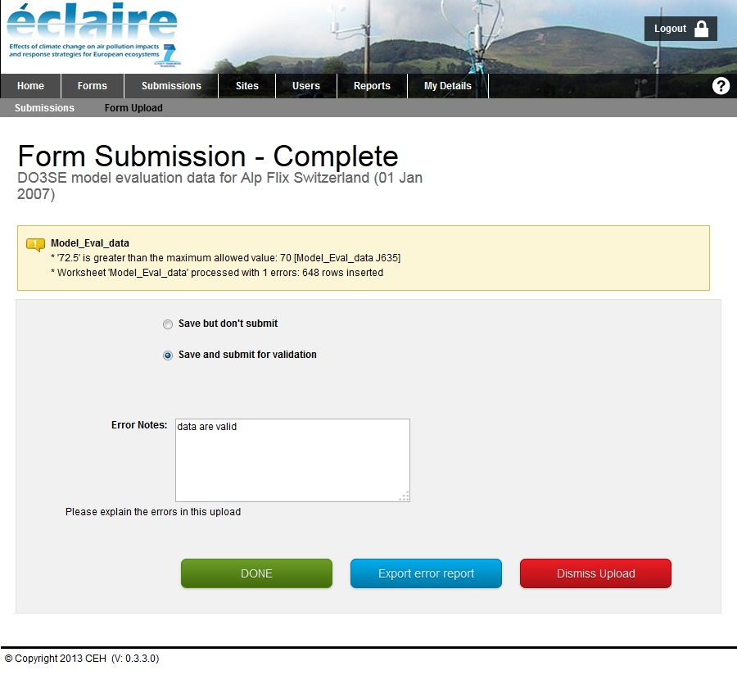

The software detected a value outside of the range defined for this field. However, the value is valid. Enter an appropriate comment in “Error notes” below. If no editing to the EXCEL file is needed, select “Save and submit for validation”, and click “DONE”

!!!!!!!!!!!!!
NEVER select this button
(it will be removed in future software enhancements)

Figure 7: Dealing with “non-fatal” errors.

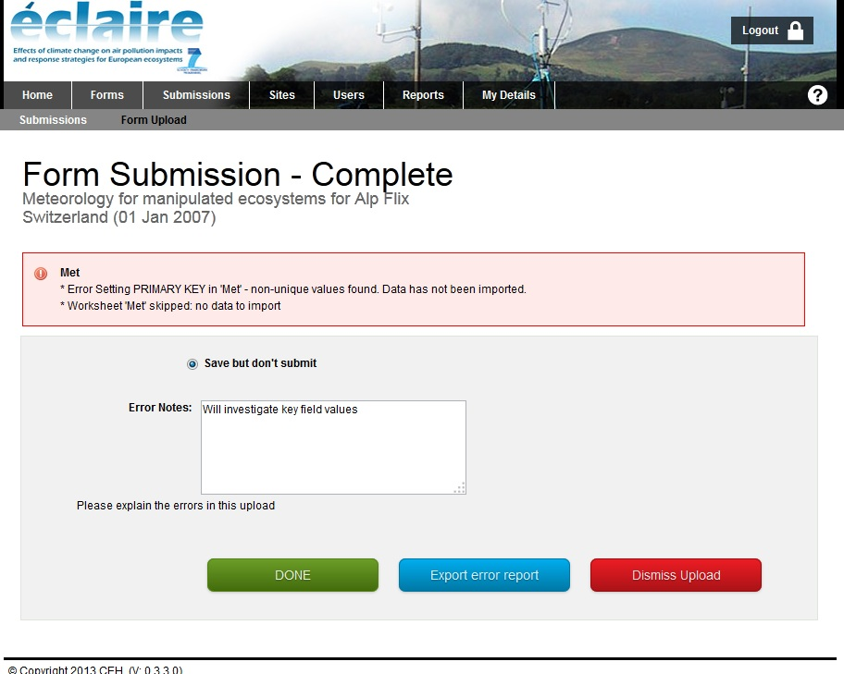

The software detected duplicate key field values – probably date /time values. Enter an appropriate comment in “Error notes” below, select “Save but don’t submit”, and click “DONE”

!!!!!!!!!!!!!
NEVER select this button
(it will be removed in future software enhancements)

Figure8: Dealing with “fatal” errors.

- Once you have clicked “Save and submit for validation”, an automatic message will be sent to the Form Manager (in this case, Sue Owen), who will check the upload and “Validate” it. Once the upload is validated, the data are available to the ECLAIRE community for downloading. Uploaders will receive an automated email to tell them when this happens.

APPENDIX A - Key fields for each worksheet of the WP1 data template

Please ensure each row of data has a unique combination of values for the key fields in each sheet
Worksheet name | Key fields
Metadata | None (upload date is picked up by the system)
Site Information | None (upload date is picked up by the system)
Ecosystem Management Details | None (upload date is picked up by the system)
Methodology | None (upload date is picked up by the system)
Your Submission comments | None (upload date is picked up by the system)
Soil properties | Date/Time  Measurement height/depth
Soil NO3 and NH4 profiles | Date/Time  Measurement height/depth
Soil gas flux NO  Soil gas flux NO2  Soil gas flux O3  Soil gas flux CO2 | Date/Time  Replicate
Meteorology soil temp profile  Meteorology soil water profile | Date/Time  Measurement height/depth
Vegetation data | Date/Time
Wet deposition | Date/Time
Gas Flux and Concentrations; VOC flux | Date/Time
Meteorology-30 min; Meteorology-1 min | Date/Time
Canopy CO2;  Canopy RH;  Canopy leaf CO2 and H2O; Canopy O3 | Date/Time

