Project: ECLAIRE, EU-FP7
Workpackage: 1.1
Date: 01/12/2011
Author: Alessandro Cescatti, JRC-IES
Review: Eiko Nemitz, CEH
Subject: Measurement protocol for FaPAR, LAI and canopy structure

1. Fraction of absorbed Photosynthetic Active Radiation (FaPAR)
The continuous monitoring of FaPAR requires the measurement of three fluxes (PARi, PARt and PARr) and of the ground reflectance (Rs) according to the following equation:

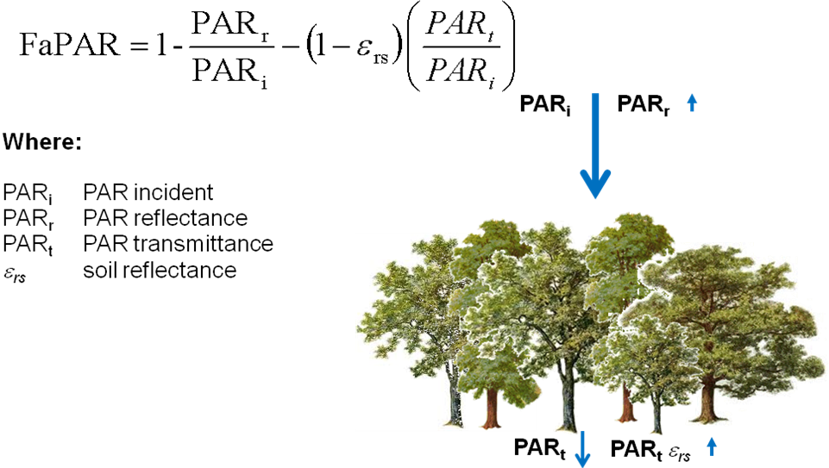
PAR sensors
Giving the large number of PAR sensors needed to estimate PARt and Rs, the cost of the sensors has to be carefully considered. From this point of view the PAR sensors SQ*** from Apogee provide good value for the money. It is important that all the PAR sensor used to assess the different PAR fluxes (except for direct/diffuse, see below) are of the same type in order to maintain consistent spectral responses.
http://www.apogeeinstruments.com/manuals/SQ-100_300manual.pdf
Pricing can be obtained online at:
http://www.apogeeinstruments.com/quantum/optionspricing.html
As an example:
- 10 sensors SQ-110 with 10 m lead length US$ 1627.80
- 1 Line Quantum Sensors (70 cm 10 sensors) US$ 438.00
An additional direct/diffuse PAR sensor has been specified by the ICOS protocol to be a Delta-T BF5 Sunshine Sensor. This needs to be installed and does not replace the total incident PAR measurement.

Data acquisition/storing
All radiative fluxes should be sampled at 1-2 sec resolution and stored as 1 min averages.
Standard 30 min averages are not sufficient.

Sampling scheme
Above canopy
Incident total PAR (PARi): 1 PAR sensor pointing upward
Incident direct/ diffuse PAR: 1 Delta-T BF5
Reflected PAR (PARr) 1 PAR sensor pointing downward
Below canopy
Transmitted PAR (PARt)
In forest ecosystems transmitted PAR (PARt) has to be monitored with a distributed array of 10-15 PAR sensors (e.g. Apogee SQ110). The number of sensors depends on canopy heterogeneity (the ICOS protocol foresees a minimum of 15 sensors per site in forest).
Sensor location can be optimized by sampling canopy transmittance (DIFN) with hemispherical photography or Licor PCA (LAI 2000, LAI 2200) on a large number of points (about 50). A selection of subset of these points is made so that the mean and standard deviation of canopy transmittance is maintained. Details and support are available for those interested in following this optimized sampling strategy.
The possibility of monitoring PARt in grassland and cropland depends on canopy height. For canopies higher than 20-30 cm, below canopy PAR measurements are feasible with line sensors (e.g. Apogee SQ311, SQ316). The ideal length of lines and number of sensors depend on the homogeneity of the canopy and has to be optimized at each site. A minimum of 10 PAR sensors is suggested.

Soil/background PAR reflectance (ε_{rs})
Forest
For continuous monitoring of ε_{rs} a minimum of 5 PAR sensors pointing downward and installed at the location of PARt sensors is required. To maximize the radiometric footprint PAR sensors pointing downward should be installed as high as possible in the trunk space (below the canopy). This setup would require another 5-15 PAR sensors.
Alternatively, episodic measurements of the ratio ε_{rs} as PARup/PARdown in the understory with a portable system build with two PAR sensors (one pointing upward and the second downward) and logged at 1 Hz. Measurements have to be integrated along a representative transect.
A commercial device that can effectively produce this measurement is the TRAC.
http://faculty.geog.utoronto.ca/Chen/Chen%27s%20homepage/res_trac.htm

Short canopies (grassland, cropland)
Episodic measurement of background reflectance can be obtained by removing vegetation from small patches and estimation of Rs as the ratio of the reflected PAR (with a downward PAR sensor) and PARi.

2. Canopy architecture
Parameters
Architectural properties of plant canopies are investigated in order to retrieve the following canopy parameters:
Plant Area Index (PAI, m²/m²): Half of the total plant surface area per unit ground area
Effective Plant Area Index (ePAI, m²/m²): Equivalent PAI under the hypothesis of random leaf distribution
Clumping coefficient (Ω, - ): ePAI/PAI
Diffuse non-interceptance (DIFN, - ): Fraction of diffuse radiation that reaches the ground
Canopy gap fraction (GF, - ): Canopy transmittance in 15 deg angular bands.
All parameters can be obtained with indirect measurements based on optical systems.

Equipment
Forest:
Single lens reflex digital camera (DSLR), ideally full frame (e.g. Nikon D700) with fish eye 8 mm lens (e.g. Sigma 8mm F3.5 EX DG). All parameters listed in the previous section can be estimated from digital images.
Cropland, Grassland:
For canopy shorter than 20 cm the indirect estimation of PAI is very challenging since the positioning of the sensors may alter the canopy. Other potential methods are:
1) Direct measurement of PAI by plant harvesting (product of the specific leaf area times the total dry mass per unit area).
2) Downward fish eye photography and estimation of canopy gap fraction by detecting the background from the canopy (colorimetric analysis of the images).
For canopies higher than 20-30 cm the following devices are suggested:
Licor Plant Canopy Analyzer (LAI 2000, LAI 2200)
http://www.licor.com/env/products/area_meters/LAI-2200/
Delta-T SunScan
http://www.delta-t.co.uk/product-display.asp?id=944&div=Plant%20Science&cat=Canopy%20Analysis
The inversion algorithms used with these devices do not allow the estimation of the clumping coefficient.

Sampling scheme
Hemispherical photographs (HP) at forest sites:
Interval: monthly (in deciduous canopies biweekly during periods of rapid LAI dynamic).
Sampling points: HP have to be takes at the same spots (30-40 points) on a grid representative of the tower flux footprint. At forest sites HP sampling points should include the spots where PARt sensors are located
Image exposure: Program mode Aperture priority and fixed f5.6-f11
Auto exposure, bracketing A-2, A, A+2
File format: RAW

Data processing
Since the processing of digital hemispherical photography can affect considerably the results it is important that all images are processed with the same algorithm/software.
JRC-IES offers centralized image processing for the project partecipants.

